FAQs
Wiston Bends
A283 Washington Road, Wiston

28 November 2022 v2

Scheme: Wiston Bends – A283 Washington Road, Wiston
Type: Embankment repairs
Road: A283 Washington Road
Parish: Wiston
WSCC Local Member: Cllr Paul Marshall
Cabinet Member: Cllr Joy Dennis
Summary
Date: November 2022
Extent: The embankment supporting the northern side of Washington Road from the access track to Horsebrook Cottage to the highway structure spanning beneath the carriageway approximately 90m to the south-east.

In November 2022 an incident occurred on A283 Washington Road and emergency repairs are required as a result. Soil testing is being undertaken to ascertain the strength of the underlying soils before we can proceed with repair works. Subject to the results of this testing, we plan to construct a retaining structure comprising rock filled gabion baskets that will be backfilled with compacted material to form a verge. Unfortunately, a tree was damaged and shall be removed to enable this solution. Following this, a crash barrier (Vehicle Restraint System) will be installed in the verge and the damaged carriageway repaired.
Traffic Management (two-way lights) is essential to keep vehicles away from the embankment and to protect the workforce and this will remain in place for the duration of the works.

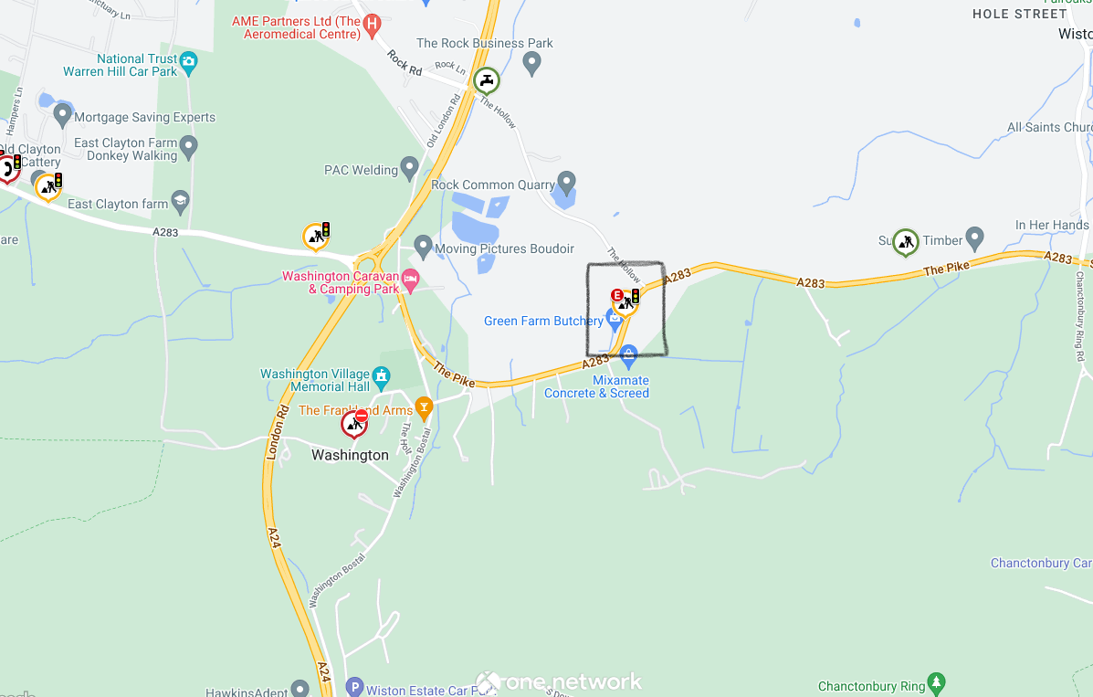

Above image shows a screenshot from One.Network of the scheme location on A283 Washington Road, East of A283 Washington Roundabout, near The Hollow junction.

Frequently Asked Questions

Q. What has happened to the road, why are there traffic lights?
A. An incident occurred on 17th November 2022 resulting in the need to undertake emergency embankment repairs. The traffic lights are in place to keep vehicles away from the embankment.

Q. Could the work be completed without the need for traffic management?
A. Due to the current condition of the embankment and for the safety of the public, site workers and highway users, it is not practical to remove traffic management until the repair works have finished. Traffic lights are manned between 07:00 and 19:00 hrs.

Q. How long will the traffic management be in place?
A. These repairs are a high priority for us, and we currently expect the duration of the works to be up to four weeks subject to any adverse weather or unexpected issues. We will of course however, do all that we can to complete the works sooner if it is possible and safe to do so.

Q. What works are being done?
We anticipate the repairs works to include –
- Removal of damaged tree

- Soil testing to ascertain the strength of the underlying soils

- Construction of a retaining structure comprising rock filled gabion baskets that will be backfilled with compacted material to form a verge

- Installation of a crash barrier (Vehicle Restraint System) in the verge
- Installation of timber post and rail fencing over the culvert
- Carriageway repairs
The main repair works will be subject to what information is found during the soil testing.
Q. When will the repair works take place?

A. The site work for the soil testing is due to be undertaken over the week commencing Monday 28th. There will then be a delay of perhaps one week while we await the results. Once we have the results, we will be in a position to finalise the design and commence the repair works. We currently expect construction to commence on Monday 5th December and last up to 4 weeks, all subject to unforeseen circumstances such as weather, resource, and materials.

Q. Can work not be undertaken 24/7 or at least shift through the night?
A. It would not be safe to work at night under lights given the location and formation of the area. Productivity of workforce is often reduced by between 20-30% during night working so this is also a consideration given the current national constraints of availability of the workforce. However, we can confirm that our contractor Landbuild Ltd shall be working weekends in order to minimise the duration of delays.

Q. I have not seen any activity on site, what is happening now?
A. Work may appear intermittent but please be assured work is not standing still. Unfortunately, there is no quick fix for this, but our engineers are expediting the design process and work will commence at the earliest opportunity. In the meantime, soil testing is being undertaken and the removal of a tree that was damaged in the recent incident.

Q. Will WSCC and the contractor be working at weekends?
A. Where possible extended working hours including weekends will be utilised. We must be mindful of several considerations including, physical site constraints, Health and safety risks for contractors and the public, impact of noise on neighbours and environmental health legislation. Availability of resource and material is also a consideration and sometimes a constraint, but it is anticipated that weekend working will form part of the works programme.

Q. Is there a diversion route in place?
A. Where this is not a road closure, a diversion route is not required. However, should highway users prefer to take an alternative route whilst the works are in construction, there are substitute routes to take by using the A24 and A27. Further information is available via one.network
Q. What environmental protection measures do you have in place during this work to ensure no detrimental effects on the wildlife, pond, and watercourse?
A. Before any construction works are undertaken, specialists will visit site and advise us of any necessary measures to protect flora and fauna and prevent pollution of the watercourse. . Whilst works are ongoing all necessary precautions are in place including emergency equipment such as Spill Kits.
One tree is due to be removed during the site clearance phase, that was damaged in the incident that occurred 17th November 2022.

Q. Is the landowner responsible happy with the works?
A. WSCC has fully engaged with the affected landowner and kept them fully informed regarding the proposed works and way of working. The landowner has been very supportive, and we are grateful for their help and understanding.

Q. Can cyclists use the road?
A. Cyclists can continue to use the highway as usual.

Q. Could weather impact the proposed works?
A. Weather conditions can have an impact on the delivery of the scheme. Wherever possible, mitigation to any delays will be put in place.

Q. I am expecting a delivery during the works. What will happen?

A. Delivery companies will still be able to use the road to attend to deliveries as usual

Q. How do I report a fault or problem on the highway?
A. The most effective way to report a fault or problem on the highway is to use our reporting application with multiple options. For further information, please visit - Make an enquiry or report a problem with a road or pavement.

